**Wildlife Sanctuary Victoria**

* **Zoo Location**

The zoo will be located in the area of Newcastle Upon Tyne, around Durham City.

* There are only 8-10 other zoos and wildlife parks.
* It is the 4th most pet-friendly and animal-friendly area in the United Kingdom.
* Good weather-only 109.5 days of rainfall a year!
* Area with large population.
* Relatively small city 🡪 short travelling time.
* Average financial status of population is good 🡪 People will visit “money worth” places, well-designed and unique 🡪 Competition with the rest of the zoos.

Source: Newcastle City Council, 2022; Met Office, 2022; Newcastle News, 2022.

* **Type of Zoo**

The type of the zoo will be protected wildlife sanctuary.

* An area where animals’ habitats and their surroundings are being protected from any sort of disturbance 🡪 animal-friendly area 🡪 great example of animal welfare.
* Exhibits including complete ecosystems.
* Only a few wildlife parks in this area.
* Unzoo
* Mixed species (because of ecosystems)
* Not very interesting for people, if it is not presented in a unique way

Source: Government website, 2022.

* **Mission statement and aims**

Mission statement:

* Create a world where animals are protected and free!

Aims:

* Preservation of wild animals’ diversity and uniqueness.
* Participation and support to breeding and reintroduction programs.
* Following the highest standards of animal care.
* Real actions and not only statements
* Indirect people forcing for behavioural change 🡪 just knowledge/education is not enough

Source: Government website, 2022.

* **Animal Species**

**Table.1 Collection information.**

|  |  |  |  |  |  |  |
| --- | --- | --- | --- | --- | --- | --- |
| Common name | Scientific name | Status in the wild | Population in the wild | Breeding | Future in collection | Number of individuals |
| European bison | *Bison bonasus* | Near threatened | 2,518 | Yes | Yes | 4 |
| Red Wolf | *Canis rufus* | Critically Endangered | 20-30 | Yes | Yes | 8 |
| Sumatran Rhinoceros | *Dicerorhinus sumatrensis* | Critically Endangered | 30 | Yes | Yes | 3 |
| Red-Billed Oxpecker | *Buphagus erythrorynchus* | Least Concern | Unknown ￬ | Yes | Yes | 45-50 |
| Yellow-Billed Oxpecker | *Buphagus africanus* | Least Concern | Unknown ￬ | Yes | Yes | 45-50 |
| Bactrian Camel | *Camelus ferus* | Critically Endangered | 950 | Yes | Yes | 5 |
| Persian Onager (Asiatic Wild Ass) | *Equus hemionus* | Near Threatened | 28,000 | Yes | Yes | 8 |
| Zebra | *Equus quagga* | Near Threatened | 150,000-250,000 | Yes | Yes | 5 |
| Ostrich | *Struthio molybdophanes* | Vulnerable | Unknown ￬ | Yes | Yes | 5 |
| Cheetah | *Acinonyx jubatus* | Vulnerable | 6,517 | Yes | Yes | 2 |
| Four-Horned Antelope | *Tetracerus quadricornis* | Vulnerable | 7,000-10,000 | Yes | Yes | 5 |
| African Forest Elephant | *Loxodonta cyclotis* | Critically Endangered | Unknown ￬ | Yes | Yes | 2 |
| Long-Tailed Macaque | *Macaca fascicularis* | Endangered | Unknown ￬ | Yes | Yes | 15 |
| White-Lipped Deer | Cervus albirostis | Vulnerable | Unknown ￬ | Yes | Yes | 5 |
| Giraffe | *Giraffa camelopardalis* | Vulnerable | 68,293 | Yes | Yes | 2 |
| Emperor Penguin | *Aptenodytes forsteri* | Nearly Threatened | Unknown ￬ | Yes | Yes | 20 |
| Tiger | *Panthera tigris* | Endangered | 2,608-3905,3140 | Yes | Yes | 3 |
| Clouded Leopard | *Neofelis nebulosa* | Vulnerable | 3,700-5,580 | Yes | Yes | 3 |
| Golden Bamboo Lemur | *Hapalemur aureus* | Critically Endangered | 50-249 | Yes | Yes | 15 |
| Marsh Deer | *Blastocerus dischotomus* | Vulnerable | Unknown ￬ | Yes | Yes | 5 |
| Mountain Caribou | *Rangifer tarandus caribou* | Critically Endangered | Unknown ￬ | Yes | Yes | 10 |
| Brown Bear | *Ursus arctos* | Least Concern | 110,000 | Yes | Yes | 5 |
| Pygmy Racoon | *Procyon pygmacus* | Critically Endangered | 192 | Yes | Yes | 10 |
| Red Panda | *Ailurus fulgens* | Endangered | Unknown ￬ | Yes | Yes | 10 |

* All species are chosen in relation to:
* Their natural environment and climate tolerance 🡪 similar to the Newcastle’s climate
* Their ability to live harmoniously with other specific species
* Their body size and the habitat range each individual needs
* All species are chosen and grouped in a way that maximase their welfare and well-being
* A problem may occur with the visibility of some animals during different periods of the day 🡪 e.g., lemurs or macaques 🡪 bigger group number chosen
* Ecosystem type of exhibits 🡪 rainforest plants, insects, river, and pond crustaceans (shrimps, crabs etc.) and fish will be included too
* Conservation value, educational value, research value 🡪 endangered species 🡪 problems with the collection of these animals may occur 🡪 collaborations with different governments and societies 🡪 breeding programs!
* Preservation of the diversity and wildlife uniqueness
* High-pulling power for visitors
* Mesh-fencing and some moat barriers will be used between exhibits
* No amphibians 🡪 difficult to be managed in group-living environments with other species 🡪 understanding from visitor’s side

**Figure.1 Decision tree**

Source: IUCN website, 2022.

* **Zoo Layout**
* The size of the sanctuary will be about 250 hectares.

**Figure.2 Sanctuary layout-outline diagram.**

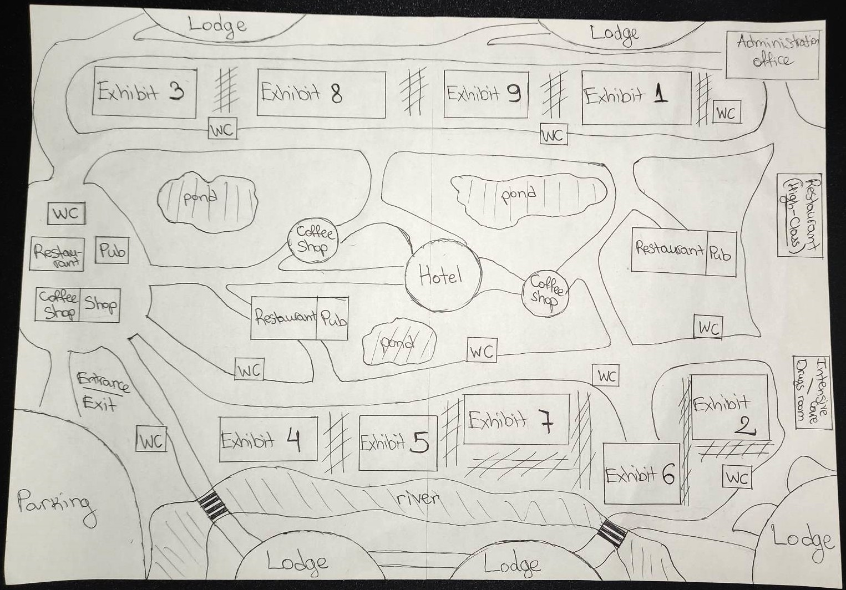

* High-pulling power for visitors 🡪 animal grouping and placement of exhibits
* Big species exhibits seperated by smaller species exhibits 🡪 balance and no risk of aggression or stress 🡪 barriers
* All exhibits will be mixed type 🡪 immersion and walk through
* Decision tree
* A problem may occur with the visibility of some animals during different periods of the day 🡪e.g., lemurs or macaques 🡪 bigger group number chosen

**Table.2 A list of the animal species and their number of individuals by exhibit.**

***\*Oxpeckers will be free over the park, approximate total number of 90-100\****

Source: LGInform website, 2022.

* **Animal Exhibits**

Type of exhibits, which will be used are **i)** “walk through” and **ii)** “immersion”.

**i) “**walk through” exhibits:

* Quantum stealth (material) will be used for the visitor’s tunnels 🡪 animals will not be able to see the visitors 🡪 no stress for the animals.
* Better experience for visitors, due to the opportunity for “closer interaction” with the animals.
* Sound neutralization, using noise cancellation devices, will be achieved in order to reduce animals’ stress even more.
* The material mentioned above, bend the light, and create “dead spots” 🡪 Light is no longer able to pass through these points, hiding the subject behind them from view, while the background remains unchanged.
* Material requires the subject or object to stand at a certain distance away in order to be concealed, and the effect might be more or less convincing when viewed from different angles. 🡪 Proper installation needed.

**ii)** “immersion” exhibits:

* Better habitat visibillity
* Interaction with animal’s modules (realistic body imitations), placed in front of each animal exhibit. 🡪 visitor’s feeling for connection with the animals.
* Tablet-like displays with information about each animal, presented in an interactive way, e.g., press and appear, mini game.
* Success in visitor’s passive education.
* Mini online test at the end of the sanctuary, including questions about animal welfare, with a chance to win a tech prize.
* Busy pathways
* All the exhibits will be provided with specifically designed equipment to help disabled people’s access and to experience the same “adventure” as everybody else!
* Weekly drive through trips will be provided at different exhibits 🡪 higher price 🡪 kind of VIP experience
* Artificial river and ponds will be included in the exhibits

**All exhibits will be mixed type** 🡪 **immersion and walk through (Table.2)**



Source: Hyperstealth website, Military, 2022.

* **Zoo Infrastructure**
* Restaurants + pub
* Affordable prices
* Table tablets with information for a random animal (animation or game form).
* Disabled access provided.
* Ventilation with filters which neutralize food smells
* Appropriate number so all visitors can be served on a very busy day.
* Coffee shops with a shop inside each one
* Affordable prices
* Entertainment for the youngest visitors (toy shops show windows)
* Table tablets with information for a random animal (animation or game form).
* Disabled access provided.
* Ventilation with filters which neutralize food smells
* Staff shortage on a very busy day
* A hotel in the middle of the sanctuary
* Hotel view of the entire sanctuary
* Window walls (where applicable) made of Quantum stealth (material).
* No stress for the animals
* Unique experience for visitors
* Disabled access provided.
* A need of limited stay policy 🡪 Availability for more bookings in busy periods.
* Toilets
* Near every exhibit
* Baby changing facility included
* Disabled toilet included
* High standard hygiene needs to be kept daily
* Intensive care facility and drugs room
* No need of animal’s transfer in an emergency

Source: Zoos Expert Committee Handbook, 2012.

* **Staffing**
* Keepers-nutritionists
* Working daily 🡪 animal welfare
* 5 keepers
* New staff every two years or so
* If not enough 🡪poor animal welfare, bad reputation
* Researchers
* Needed for different programs
* Not needed daily
* Sanctuary will be opened to universities for research
* Vets
* One vet needed for daily check-ups
* Vets on-call for emergencies (from vet wildlife centres)
* Administration
* Fund raising, human resources, marketing
* 1-2 offices
* Consultants
* Landscape architects
* Tech-experts
* A group of 2-3
* Restaurants and coffee shops staff
* Hotel and lodges staff

Source: BIAZA, 2022.

* **Entry cost and** **sponsorship/funding**
* Entry cost:
* £18 per adult
* £12 per kids (5-16 yo)
* FREE for kids under 5 yo
* £15 per senior (65+)
* £15 per student
* £3 off for disabled adults/kids
* £45 - Family pack (2 adults and 2 kids)
* Annual memberships
* £80 – single adult
* £120 - joint adult
* £70 – student
* £230 – family pack
* Affordable prices
* Prices’ representation of sanctuary’s priority (animal welfare and conservation) 🡪 high prices will mean staff wage’s priority
* Family packs option
* Annual membership options
* Discounts:
* 10% for online bookings
* 15% for travelling by bike/public transport/electric vehicle
* 10% cashback from ticket price on 3rd visit in 2 months
* Variable pricing on busy periods of the year
* Sponsorship/funding:
* Wildlife and conservation organisations (sponsors)
* Government and celebrities (funders)
* Celebrities’ funding through fund raising events – e.g., concerts or different colaborations (commercial sponsorship) 🡪 concerts will be based on places outside the sanctuary
* Government through grants
* Annual memberships
* Hotel
* Shop’s sales
* Animal adoptions
* Lower price for endangered species 🡪 more adoptions
* VIP activities
* Luxury lodges near a few exhibits
* A high-class restaurant
* Ideal place for a date
* Rainforest theme – animated walls, decorations

Source: Northumberland Zoo price list, 2022.

* **Future**
* Investments:
* Collaborations with celebrities and social media (tiktok, instagram, twitter) 🡪 better advertising 🡪 age group 16-25 better attracted
* More species and new exhibits
* Innovations in the technology used in the sanctuary (global evolution of technology annualy)
* If there is quite big income 🡪 more discounts and an idea for an annual prize draw (money from tickets will go only towards animals and not wages)
* Innovations in already existed exhibits
* Innovations in sanctuary’s infrastructure aggreed with the global infrastructure’s evolution and trends

**Figure.3 Sanctuary plan for the next 10 years.**

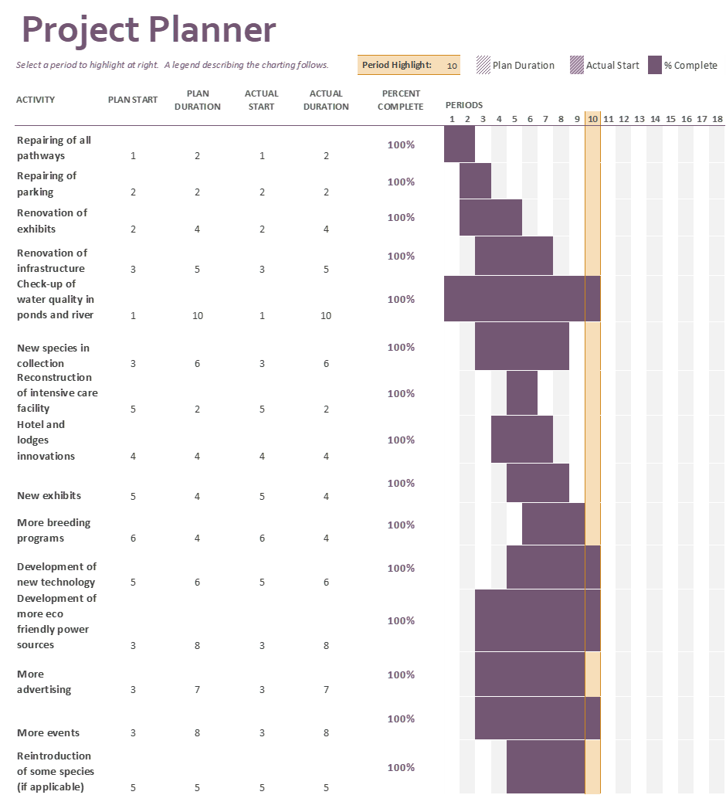

* Returning visitors 🡪 more income
* Sanctuary will be a strong competition for the rest nearby
* Everything needs to be done in time
* Some actions may need to be done more than once
* Changes may occur due to financial difficulties (if applicable)

Source: EAZA, 2013

* **References**

BIAZA, 2022. *Rising to the Challenge*

<https://biaza.org.uk/userfiles/userfiles/file/jobs%20and%20careers%20in%20zoos%20guide.pdf> Accessed on [10/11/2022].

Defra, 2012. *Department for Environment Food & Rural Affairs: Zoos Expert Committee Handbook* <https://assets.publishing.service.gov.uk/government/uploads/system/uploads/attachment_data/file/69611/pb13815-zoos-expert-committee-handbook1.pdf>Accessed on [10/11/2022].

EAZA, 2013. *The Modern Zoo: Foundations for Management and development*

<https://www.eaza.net/assets/Uploads/images/Membership-docs-and-images/Zoo-Management-Manual-compressed.pdf> Accessed on [12/11/2022].

Gleadow, E., 2022. *News: Newcastle ranked as fourth most pet-friendly city in all of UK.*

<https://www.newcastleworld.com/news/newcastle-ranked-as-fourth-most-pet-friendly-city-in-all-of-uk-3745367> Accessed on [3/11/2022].

Government, 2022. *Environmental management: Wildlife and habitat conservation: detailed information*

<https://www.gov.uk/topic/environmental-management/wildlife-habitat-conservation> Accessed on [8/11/2022].

Government, 2022. *Met Office Weather*

<https://www.metoffice.gov.uk> Accessed on [3/11/2022].

Government, 2022. *Newcastle City Council*

<https://community.newcastle.gov.uk/mapping/home> Accessed on [3/11/2022].

Government, 2022. *Outdoor access and recreation*

<https://www.gov.uk/topic/outdoor-access-recreation/parks-trails-nature-reserves> Accessed on [8/11/2022].

Hyperstealth, 2022. *Quantum Stealth: The Invisible Military Becomes A Reality*

<https://www.hyperstealth.com/Quantum-Stealth/> Accessed on [9/11/2022].

IUCN, 2022. *The IUCN Red List of Threatened Species.* Version 2022-1.

<https://www.iucnredlist.org> Accessed on [15/11/2022].

Northumberland Zoo, 2022. *Prices*

<https://www.northumberlandzoo.co.uk/plan-your-visit/prices> Accessed on [11/11/2022].

Office for National Statistics, 2022. <https://lginform.local.gov.uk/reports/lgastandard?mod-area=E92000001&mod-group=AllLaInCountry_England&mod-metric=442&mod-period=3&mod-type=namedComparisonGroup> Accessed on [9/11/2022].